GDPR UAT Guide

Grainger PLC
GDPR AnonymiSation

Version 1.0
July 29, 2024

1 Introduction 3
1.1 Document purpose 3
1.2 Intended audience 3
1.3 Anonymisation Process overview 3
2 Testing 5
2.1 High level testing strategy 5
2.2 Identifying records for anonymisation 5
2.2.1 Leads 5
2.2.2 Contacts 11
2.3 Marketing cloud Opt-in process 17
2.3.1 Leads 17
2.3.2 Contacts 18
2.4 Error emails 19
2.5 Sanity testing 19

Introduction

Document purpose
- Clarify the Implemented Solution and Steps for Grainger UAT Testing

- Detail the Identification Process for GDPR-Compliant Records

- Describe the Anonymisation Process and Field Alterations for Each Object

- Demonstrate the Functionality of the Marketing Cloud Opt-In Email

- Explain the Error Email Mechanism

Intended audience
The document is intended for the following:
- Grainger UAT testers

Anonymisation Process overview

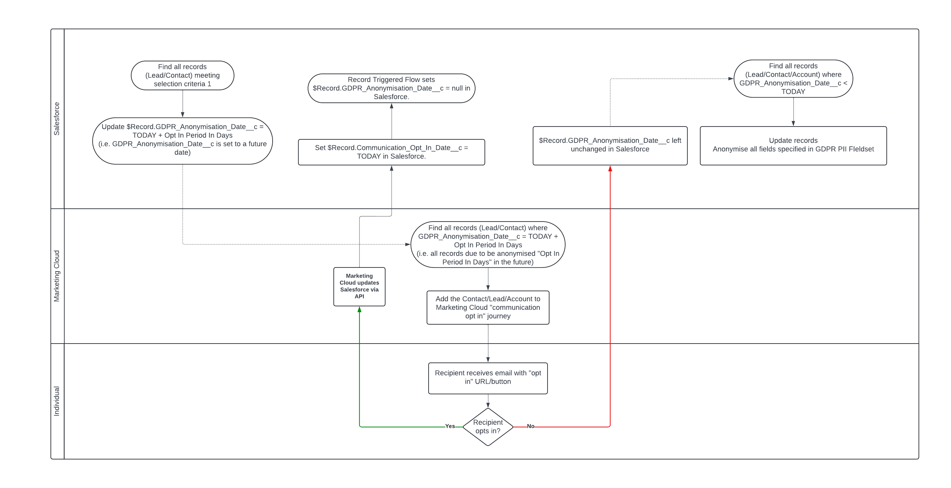

- The anonymisation process will be scheduled to run every morning at 9am BST and will include all records meeting the criteria for anonymisation
- ‘GDPR Anonymisation Date’ field will get date stamped with (today’s date + Opt-In In period)
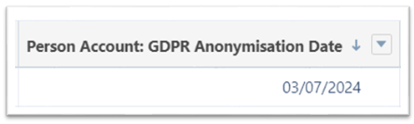

- Marketing Cloud implementation will send out the Opt-In email
- Data will be anonymised with anonymised values if the “Communication Opt In Date” is null or is older than 365 days
- Names and email fields will be assigned random unique text strings to avoid duplicate values

- GDPR Anonymised (checkbox) will be set to ‘TRUE’ to indicate record has been anonymised
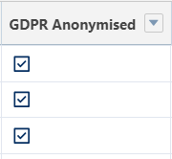
- Field Audit History for PII fields of anonymised records will be deleted. The field history can be viewed by selecting the records related list and navigating to the Lead / Contact / Person Account history related list, field anonymisation changes will be tracked here

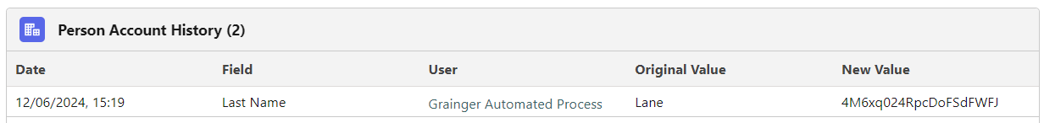

Testing

High level testing strategy
The batch job will run automatically over a number of successive days. On each day we will:
- Identify records to be anonymised and confirm existing data and number of records
- For all candidate records due to be anonymised, validate that:
  - The “GDPR Anonymisation Date” field is stamped with <TODAY> + <Opt-In In period>
  - The “GDPR Anonymised” checkbox is set to ‘TRUE’.
We will use a report/SOQL to validate numbers of records match expected “anonymisation candidate” numbers”
- When the batch runs and picks up records where “GDPR Anonymisation Date” = <TODAY>, validate data has been anonymised according to fieldsets and field history is deleted by doing a manual inspection of sample records.
- Confirm that setting the “Communication Opt In Date” field will prevent a record from being anonymised for a further year. Validate by updating sample records and confirming subsequent batch jobs do not anonymise them.
- If there is a discrepancy in results check for error email.

Identifying records for anonymisation
We will identify the total number of records that meet the criteria of anonymisation before the process runs, then once complete the results of expected records can be compared to the list of records anonymised and any exceptions can be identified

Leads
When the anonymisation batch runs on any given day, a Lead is considered to be a “candidate for anonymisation” when it meets the conditions below:
- A Lead has a created date more than 1 year ago
- Lead is not converted
- Lead has not opted in after the communication email was sent
- Communication Opt-In Date is not 365 or more days prior to today

Then GDPR Anonymisation Date is set to Today + 1 days for Opt-in Communication window. (Opt-in Communication window will be 14 days when running in PROD)

The report saved in a GDPR folder in UAT https://graingerplc--uat.sandbox.lightning.force.com/lightning/r/Report/00OPv000004Br6jMAC/view?queryScope=userFolders shows all unconverted Leads created more than 365 days ago, grouped to show numbers of records by CreatedDate. We will use this to confirm that the expected numbers of records are being processed.

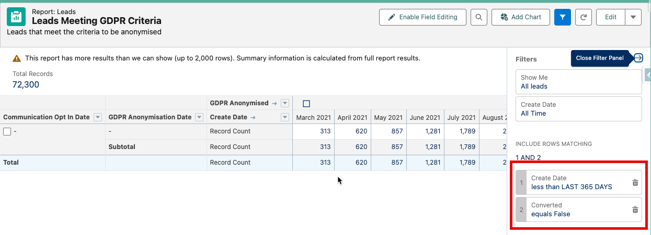

The report at https://graingerplc--uat.sandbox.lightning.force.com/lightning/r/Report/00OPv000004Q5BRMA0/view?queryScope=userFolders shows some sample leads that will be anonymised. We will use this for quantitative testing to see the anonymised values put into the PII fields.

These records are all candidates for the anonymisation process. During successive days during the UAT, we are expecting to see:

Day 1 (2024-07-23) – before the batch job has been scheduled
All Day 1 candidate Lead records (all unconverted Leads created more than 365 days ago, on or before 2023-07-23) will have:
  - GDPR_Anonymised__c = FALSE
  - GDPR_Anonymisation_Date__c = NULL
  - Communication_Opt_In_Date__c = NULL

Day 2 (2024-07-24) – after the batch job has been run for the first time (automatically via scheduled batch job)

All Day 2 candidate Lead records (all unconverted Leads created more than 365 days ago, on or before 2023-07-24) will have been updated to have:
  - GDPR_Anonymised__c = FALSE
  - GDPR_Anonymisation_Date__c = 2024-07-25 (<Day 2> + 1 days)
  - Communication_Opt_In_Date__c = NULL

Day 3 (2024-07-25) – after the batch job has been run for the second time (automatically via scheduled batch job)

All Day 2 candidate Lead records will have been left unchanged to have:
  - GDPR_Anonymised__c = FALSE
  - GDPR_Anonymisation_Date__c = 2024-07-25 (<Day 2> + 1 days)
  - Communication_Opt_In_Date__c = NULL
  - For a subset of these Day 2 candidate records, we will then manually update Communication_Opt_In_Date__c = 2024-07-26 to simulate the process by which a lead can opt in via Marketing Cloud

New Day 3 candidate Lead records (i.e. a small number of records that were created 365 days ago, on 2023-07-25) will have been updated to have:
  - GDPR_Anonymised__c = FALSE
  - GDPR_Anonymisation_Date__c = 2024-07-26 (<Day 3> + 1 days)
  - Communication_Opt_In_Date__c = NULL

Day 4 (2024-07-26) – after the batch job has been run for the third time (automatically via scheduled batch job)

All Day 2 candidate Lead records:
  - Where Communication_Opt_In_Date__c = NULL (i.e. records that need to be anonymised as the lead has not opted in) will have been updated to have:
    - GDPR_Anonymised__c = TRUE
    - GDPR_Anonymisation_Date__c = 2024-07-25 (<Day 2> + 1 days)
    - Communication_Opt_In_Date__c = NULL
    - PII fields as per field set below will be anonymised as per https://graingerplc.atlassian.net/browse/GA-3
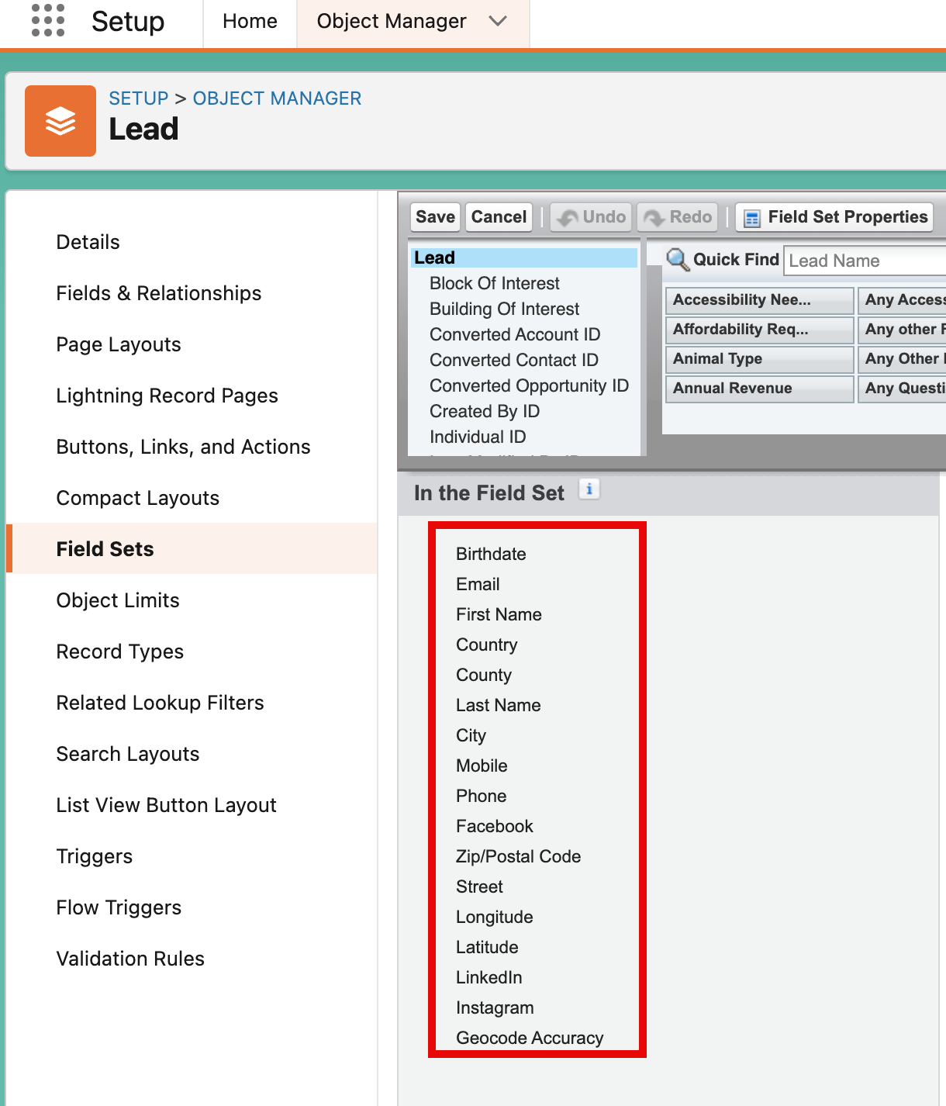
Figure 1 Lead PII Fieldset
    - Field audit history records for the anonymised records will be deleted as per https://graingerplc.atlassian.net/browse/GA-8

  - Where Communication_Opt_In_Date__c != NULL (i.e. where the Lead has opted in to communications) will have been updated to have:
    - GDPR_Anonymised__c = FALSE
    - GDPR_Anonymisation_Date__c = NULL
    - Communication_Opt_In_Date__c = 2024-07-26
    - For a subset of these records, we will then manually update Communication_Opt_In_Date__c = 2023-07-25 to simulate the scenario where the Opt in is more than 365 days in the past and the records are again eligible for anonymisation. This subset will be referred to as “Day 2 Leads with expired Opt in Date”.

Day 3 candidate Lead records (i.e. a small number of records that were created 365 days ago, on 2023-07-25) will have been left unchanged to have:
  - GDPR_Anonymised__c = FALSE
  - GDPR_Anonymisation_Date__c = 2024-07-26 (<Day 3> + 1 days)
  - Communication_Opt_In_Date__c = NULL

New Day 4 candidate Lead records (i.e. a small number of records that were created 365 days ago, on 2023-07-26) will have been updated to have:
  - GDPR_Anonymised__c = FALSE
  - GDPR_Anonymisation_Date__c = 2024-07-27 (<Day 4> + 1 days)
  - Communication_Opt_In_Date__c = NULL

Day 5 (2024-07-27) – after the batch job has been run for the fourth time (automatically via scheduled batch job)

All Day 2 candidate Lead records will remain unchanged, except for “Day 2 Leads with expired Opt in Date”. These will have been will have been updated to have:
    - GDPR_Anonymised__c = FALSE
    - GDPR_Anonymisation_Date__c = 2024-07-28 (<Day 5> + 1 days)
    - Communication_Opt_In_Date__c = 2023-07-25
    - i.e. we are validating that candidate records with an Opt In Date more than 365 days in the past are put back into the anonymisation process

All Day 3 candidate Lead records:
  - Where Communication_Opt_In_Date__c = NULL will have been updated to have:
    - GDPR_Anonymised__c = TRUE
    - GDPR_Anonymisation_Date__c = 2024-07-26 (<Day 3> + 1 days)
    - Communication_Opt_In_Date__c = NULL
    - PII fields as per field set in Figure 1 will be anonymised as per https://graingerplc.atlassian.net/browse/GA-3
    - Field audit history records for the anonymised records will be deleted as per https://graingerplc.atlassian.net/browse/GA-8
All Day 4 candidate Lead records will have been left unchanged to have:
  - GDPR_Anonymised__c = FALSE
  - GDPR_Anonymisation_Date__c = 2024-07-27 (<Day 4> + 1 days)
  - Communication_Opt_In_Date__c = NULL

New Day 5 candidate Lead records (i.e. a small number of records that were created 365 days ago, on 2023-07-27) will have been updated to have:
  - GDPR_Anonymised__c = FALSE
  - GDPR_Anonymisation_Date__c = 2024-07-28 (<Day 5> + 1 days)
  - Communication_Opt_In_Date__c = NULL

Day 6 (2024-07-28) – after the batch job has been run for the fifth time (automatically via scheduled batch job)

All Day 2 candidate Lead records will remain unchanged (they have been anonymised and don’t need to be updated)

“Day 2 Leads with expired Opt in Date” records will remain unchanged (they are waiting to be anonymised on the following day once the opt in period expires).

All Day 3 candidate Lead records will remain unchanged (they have been anonymised and don’t need to be updated)

All Day 4 candidate Lead records:
  - Where Communication_Opt_In_Date__c = NULL will have been updated to have:
    - GDPR_Anonymised__c = TRUE
    - GDPR_Anonymisation_Date__c = 2024-07-27 (<Day 4> + 1 days)
    - Communication_Opt_In_Date__c = NULL
    - PII fields as per field set in Figure 1 will be anonymised as per https://graingerplc.atlassian.net/browse/GA-3
    - Field audit history records for the anonymised records will be deleted as per https://graingerplc.atlassian.net/browse/GA-8
Day 5 candidate Lead records will have been left unchanged to have:
  - GDPR_Anonymised__c = FALSE
  - GDPR_Anonymisation_Date__c = 2024-07-28 (<Day 5> + 1 days)
  - Communication_Opt_In_Date__c = NULL

Day 7 (2024-07-29) – after the batch job has been run for the sixth time (automatically via scheduled batch job)

All Day 2 candidate Lead records will remain unchanged (they have been anonymised and don’t need to be updated)

“Day 2 Leads with expired Opt in Date” records will will have been updated to have:
    - GDPR_Anonymised__c = TRUE
    - GDPR_Anonymisation_Date__c = 2024-07-28 (<Day 5> + 1 days)
    - Communication_Opt_In_Date__c = 2023-07-25
    - PII fields as per field set in Figure 1 will be anonymised as per https://graingerplc.atlassian.net/browse/GA-3
    - Field audit history records for the anonymised records will be deleted as per https://graingerplc.atlassian.net/browse/GA-8
    - i.e. we are validating that candidate records with an Opt In Date more than 365 days in the past are anonymised

All Day 3 candidate Lead records will remain unchanged (they have been anonymised and don’t need to be updated)

All Day 4 candidate Lead records will remain unchanged (they have been anonymised and don’t need to be updated)

All Day 5 candidate Lead records:
  - Where Communication_Opt_In_Date__c = NULL will have been updated to have:
    - GDPR_Anonymised__c = TRUE
    - GDPR_Anonymisation_Date__c = 2024-07-28 (<Day 5> + 1 days)
    - Communication_Opt_In_Date__c = NULL
    - PII fields as per field set in Figure 1 will be anonymised as per https://graingerplc.atlassian.net/browse/GA-3
    - Field audit history records for the anonymised records will be deleted as per https://graingerplc.atlassian.net/browse/GA-8
Day 6 candidate Lead records will have been left unchanged to have:
  - GDPR_Anonymised__c = FALSE
  - GDPR_Anonymisation_Date__c = 2024-07-29 (<Day 6> + 1 days)
  - Communication_Opt_In_Date__c = NULL

Contacts
Note: Updates to Contact records will automatically update the PersonAccount record due to standard Salesforce functionality, hence no testing is done specifically on the Account object.
When the anonymisation batch runs on any given day, a Contact is considered to be a “candidate for anonymisation” when it meets the conditions below:

- If a record is created more than 1 year ago AND
- Does not have a contact role in a Closed Won opportunity (active, inactive) AND
- Does not have a contact role in an open opportunity created less than 365 days ago
(active and inactive) AND
- Has NOT opted in after communication email was sent

The query below can be run in Salesforce inspector to identify total number of Contacts that meet anonymisation criteria. It’s necessary to use a SOQL query instead of report due to the complexity of the filter criteria used to identify Contact records to be anonymised – specifically that the contacts cannot be included in any OpportunityContactRoles for Closed Won opportunities.

SELECT createddate,Id, Name, Email, GDPR_Anonymised__c, GDPR_Anonymisation_Date__c,Communication_Opt_In_Date__c FROM Contact
WHERE Id NOT IN (SELECT ContactId FROM OpportunityContactRole WHERE Opportunity.StageName = 'Closed Won')
AND Id NOT IN (SELECT ContactId FROM OpportunityContactRole WHERE Opportunity.StageName != 'Closed Won' AND Opportunity.CreatedDate = LAST_N_DAYS:365)
AND CreatedDate < LAST_N_DAYS:341

The results from the query should then be put into Excel

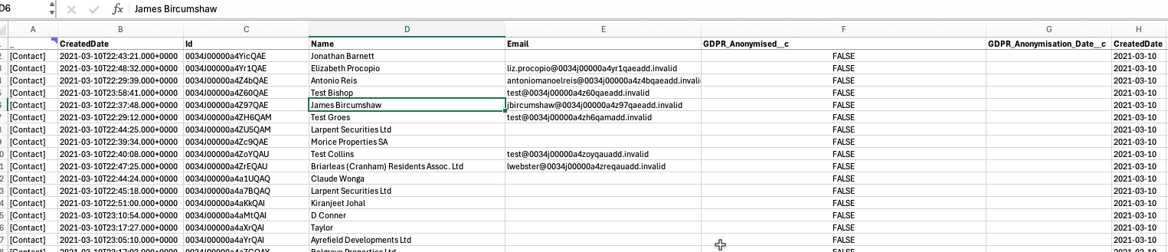

A pivot table will then show the number of records we are expecting to see being flagged for anonymisation each day when the batch job runs.

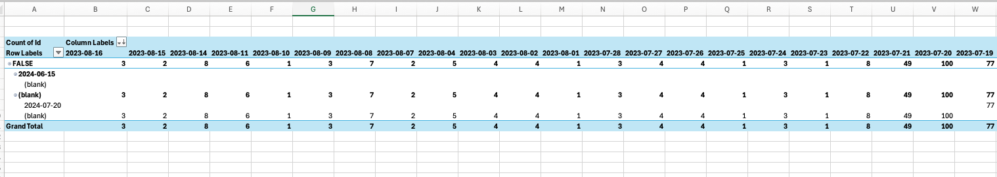

The report at https://graingerplc--uat.sandbox.lightning.force.com/lightning/r/Report/00OPv000004Q5D3MAK/view?queryScope=userFolders shows some sample Contacts that will be anonymised. We will use this for quantitative testing to see the anonymised values put into the PII fields.

These records are all candidates for the anonymisation process. During successive days during the UAT, we are expecting to see:

Day 1 (2024-07-23) – before the batch job has been scheduled
All Day 1 candidate Contact records (all Contacts created more than 365 days ago without any OpportunityContactRole connected to a Closed Won Opportunity) will have:
  - GDPR_Anonymised__c = FALSE
  - GDPR_Anonymisation_Date__c = NULL
  - Communication_Opt_In_Date__c = NULL

Day 2 (2024-07-24) – after the batch job has been run for the first time (automatically via scheduled batch job)

All Day 2 candidate Contact records (all Contacts created more than 365 days ago, on or before 2023-07-24 without any OpportunityContactRole connected to a Closed Won Opportunity) will have been updated to have:
  - GDPR_Anonymised__c = FALSE
  - GDPR_Anonymisation_Date__c = 2024-07-25 (<Day 2> + 1 days)
  - Communication_Opt_In_Date__c = NULL

Day 3 (2024-07-25) – after the batch job has been run for the second time (automatically via scheduled batch job)

All Day 2 candidate Contact records will have been left unchanged to have:
  - GDPR_Anonymised__c = FALSE
  - GDPR_Anonymisation_Date__c = 2024-07-25 (<Day 2> + 1 days)
  - Communication_Opt_In_Date__c = NULL
  - For a subset of these Day 2 candidate records, we will then manually update Communication_Opt_In_Date__c = 2024-07-26 to simulate the process by which a contact can opt in via Marketing Cloud

New Day 3 candidate Contact records (i.e. a small number of records that were created 365 days ago, on 2023-07-25) will have been updated to have:
  - GDPR_Anonymised__c = FALSE
  - GDPR_Anonymisation_Date__c = 2024-07-26 (<Day 3> + 1 days)
  - Communication_Opt_In_Date__c = NULL

Day 4 (2024-07-26) – after the batch job has been run for the third time (automatically via scheduled batch job)

All Day 2 candidate Contact records:
  - Where Communication_Opt_In_Date__c = NULL (i.e. records that need to be anonymised as the lead has not opted in) will have been updated to have:
    - GDPR_Anonymised__c = TRUE
    - GDPR_Anonymisation_Date__c = 2024-07-25 (<Day 2> + 1 days)
    - Communication_Opt_In_Date__c = NULL
    - PII fields as per field set below will be anonymised as per https://graingerplc.atlassian.net/browse/GA-3
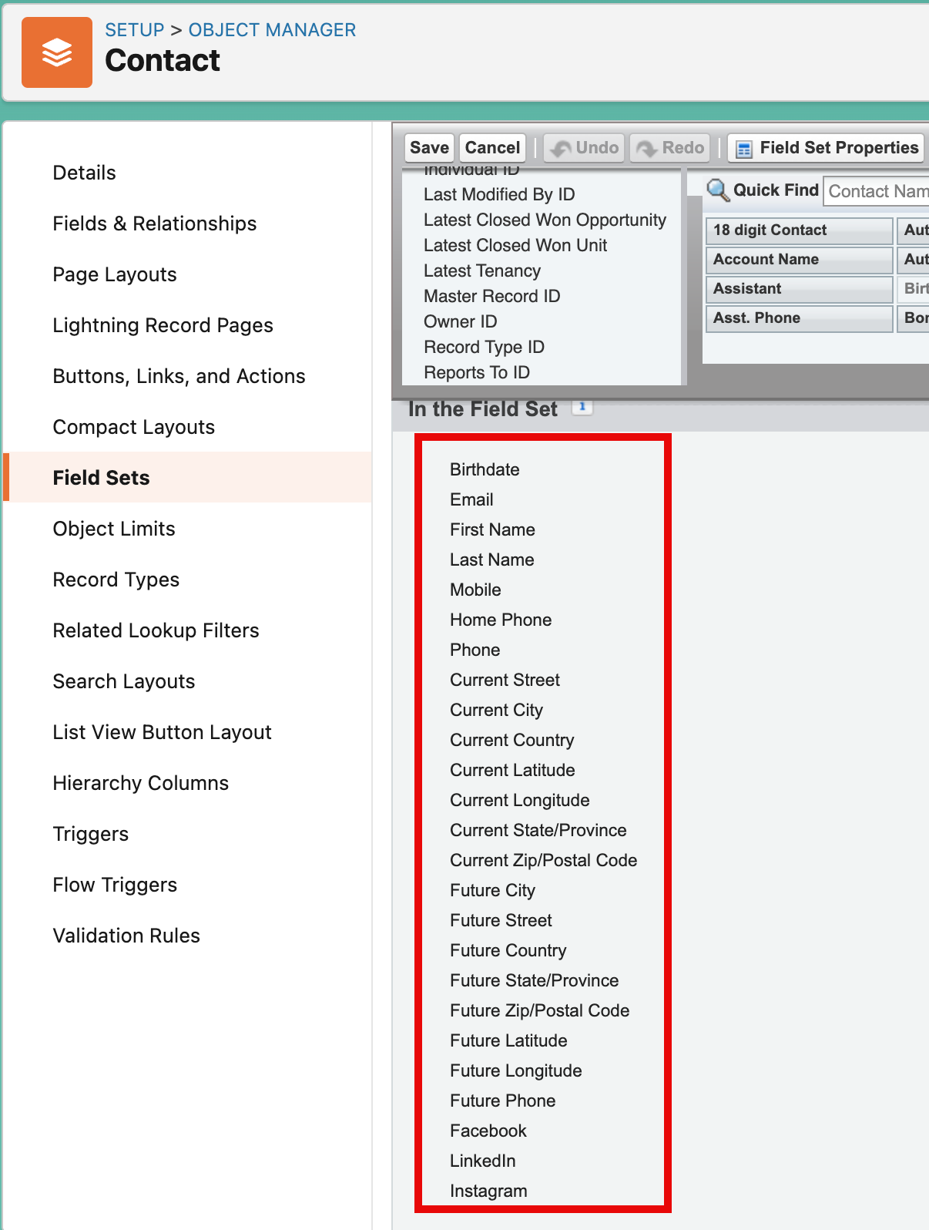
Figure 2 Contact PII Fieldset
    - Field audit history records for the anonymised records will be deleted as per https://graingerplc.atlassian.net/browse/GA-8

  - Where Communication_Opt_In_Date__c != NULL (i.e. where the Contact has opted in to communications) will have been updated to have:
    - GDPR_Anonymised__c = FALSE
    - GDPR_Anonymisation_Date__c = NULL
    - Communication_Opt_In_Date__c = 2024-07-25
    - For a subset of these records, we will then manually update Communication_Opt_In_Date__c = 2023-07-25 to simulate the scenario where the Opt in is more than 365 days in the past and the records are again eligible for anonymisation. This subset will be referred to as “Day 2 Contacts with expired Opt in Date”.

Day 3 candidate Contact records (i.e. a small number of records that were created 365 days ago, on 2023-07-25) will have been left unchanged to have:
  - GDPR_Anonymised__c = FALSE
  - GDPR_Anonymisation_Date__c = 2024-07-26 (<Day 3> + 1 days)
  - Communication_Opt_In_Date__c = NULL

New Day 4 candidate Contact records (i.e. a small number of records that were created 365 days ago, on 2023-07-26) will have been updated to have:
  - GDPR_Anonymised__c = FALSE
  - GDPR_Anonymisation_Date__c = 2024-07-27 (<Day 4> + 1 days)
  - Communication_Opt_In_Date__c = NULL

Day 5 (2024-07-27) – after the batch job has been run for the fourth time (automatically via scheduled batch job)

All Day 2 candidate Contact records will remain unchanged, except for “Day 2 Contacts with expired Opt in Date”. These will have been will have been updated to have:
    - GDPR_Anonymised__c = FALSE
    - GDPR_Anonymisation_Date__c = 2024-07-28 (<Day 5> + 1 days)
    - Communication_Opt_In_Date__c = 2023-07-25
    - i.e. we are validating that candidate records with an Opt In Date more than 365 days in the past are put back into the anonymisation process

All Day 3 candidate Contact records:
  - Where Communication_Opt_In_Date__c = NULL will have been updated to have:
    - GDPR_Anonymised__c = TRUE
    - GDPR_Anonymisation_Date__c = 2024-07-26 (<Day 3> + 1 days)
    - Communication_Opt_In_Date__c = NULL
    - PII fields as per field set in Figure 2 will be anonymised as per https://graingerplc.atlassian.net/browse/GA-3
    - Field audit history records for the anonymised records will be deleted as per https://graingerplc.atlassian.net/browse/GA-8
All Day 4 candidate Contact records will have been left unchanged to have:
  - GDPR_Anonymised__c = FALSE
  - GDPR_Anonymisation_Date__c = 2024-07-27 (<Day 4> + 1 days)
  - Communication_Opt_In_Date__c = NULL

New Day 5 candidate Contact records (i.e. a small number of records that were created 365 days ago, on 2023-07-27) will have been updated to have:
  - GDPR_Anonymised__c = FALSE
  - GDPR_Anonymisation_Date__c = 2024-07-28 (<Day 5> + 1 days)
  - Communication_Opt_In_Date__c = NULL

Day 6 (2024-07-28) – after the batch job has been run for the fifth time (automatically via scheduled batch job)

All Day 2 candidate Contact records will remain unchanged (they have been anonymised and don’t need to be updated)

“Day 2 Contact with expired Opt in Date” records will remain unchanged (they are waiting to be anonymised on the following day once the opt in period expires).

All Day 3 candidate Contact records will remain unchanged (they have been anonymised and don’t need to be updated)

All Day 4 candidate Contact records:
  - Where Communication_Opt_In_Date__c = NULL will have been updated to have:
    - GDPR_Anonymised__c = TRUE
    - GDPR_Anonymisation_Date__c = 2024-07-27 (<Day 4> + 1 days)
    - Communication_Opt_In_Date__c = NULL
    - PII fields as per field set in Figure 2 will be anonymised as per https://graingerplc.atlassian.net/browse/GA-3
    - Field audit history records for the anonymised records will be deleted as per https://graingerplc.atlassian.net/browse/GA-8
Day 5 candidate Contact records will have been left unchanged to have:
  - GDPR_Anonymised__c = FALSE
  - GDPR_Anonymisation_Date__c = 2024-07-28 (<Day 5> + 1 days)
  - Communication_Opt_In_Date__c = NULL

Day 7 (2024-07-29) – after the batch job has been run for the sixth time (automatically via scheduled batch job)

All Day 2 candidate Contact records will remain unchanged (they have been anonymised and don’t need to be updated)

“Day 2 Contact with expired Opt in Date” records will have been updated to have:
    - GDPR_Anonymised__c = TRUE
    - GDPR_Anonymisation_Date__c = 2024-07-28 (<Day 5> + 1 days)
    - Communication_Opt_In_Date__c = 2023-07-25
    - PII fields as per field set in Figure 2 will be anonymised as per https://graingerplc.atlassian.net/browse/GA-3
    - Field audit history records for the anonymised records will be deleted as per https://graingerplc.atlassian.net/browse/GA-8
    - i.e. we are validating that candidate records with an Opt In Date more than 365 days in the past are anonymised

All Day 3 candidate Contact records will remain unchanged (they have been anonymised and don’t need to be updated)

All Day 4 candidate Contact records will remain unchanged (they have been anonymised and don’t need to be updated)

All Day 5 candidate Contact records:
  - Where Communication_Opt_In_Date__c = NULL will have been updated to have:
    - GDPR_Anonymised__c = TRUE
    - GDPR_Anonymisation_Date__c = 2024-07-28 (<Day 5> + 1 days)
    - Communication_Opt_In_Date__c = NULL
    - PII fields as per field set in Figure 2 will be anonymised as per https://graingerplc.atlassian.net/browse/GA-3
    - Field audit history records for the anonymised records will be deleted as per https://graingerplc.atlassian.net/browse/GA-8
Day 6 candidate Contact records will have been left unchanged to have:
  - GDPR_Anonymised__c = FALSE
  - GDPR_Anonymisation_Date__c = 2024-07-29 (<Day 6> + 1 days)
  - Communication_Opt_In_Date__c = NULL

Marketing cloud Opt-in process
A Marketing Cloud journey will send out the Opt-In email to all records that meet the anonymisation criteria when the GDPR_Anonymisation_Date__c is first set. The email will contain a link for the contact to opt-in to communications from Grainger. Clicking on this link will cause Marketing Cloud to update the Contact/Lead record in Salesforce and will prevent the record from being anonymised for another year.
Testing the Marketing Cloud opt in process will be done in PROD because there is no UAT environment for Marketing Cloud.

Leads
A report has been created in PROD at https://graingerplc.lightning.force.com/lightning/r/Report/00ONz000005j9DxMAI/view

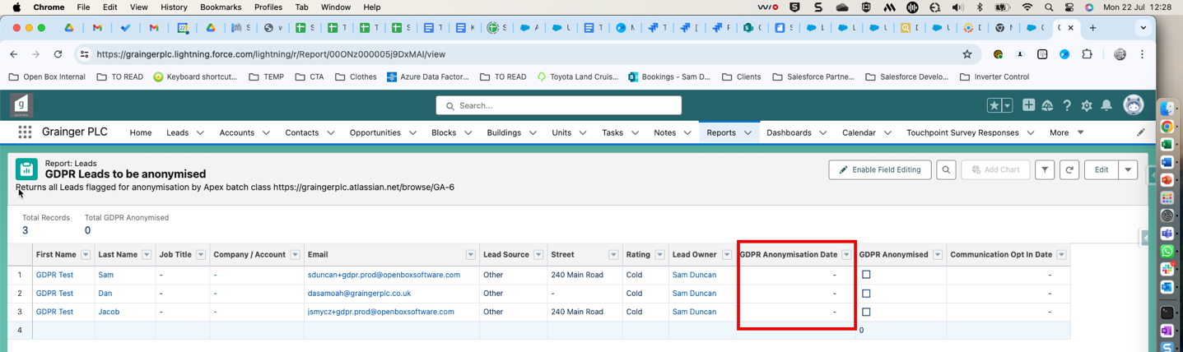

This will return specific dummy Lead records that have been created for testing purposes. All of these Lead records have “Communication Opt In Date” = NULL.

Marketing Cloud will initiate a journey using this report for source data, sending an email to all records returned by the report.

When the recipient from above report receives the email, if they click on the “Opt In URL” we are expecting the corresponding Lead record in Salesforce to be updated to have “Communication Opt In Date” = <TODAY>.

Contacts

A report has been created in PROD at https://graingerplc.lightning.force.com/lightning/r/Report/00ONz000005iq1dMAA/edit. This will return specific dummy Contact records that have been created for testing purposes. All of these Contact records have “Communication Opt In Date” = NULL.

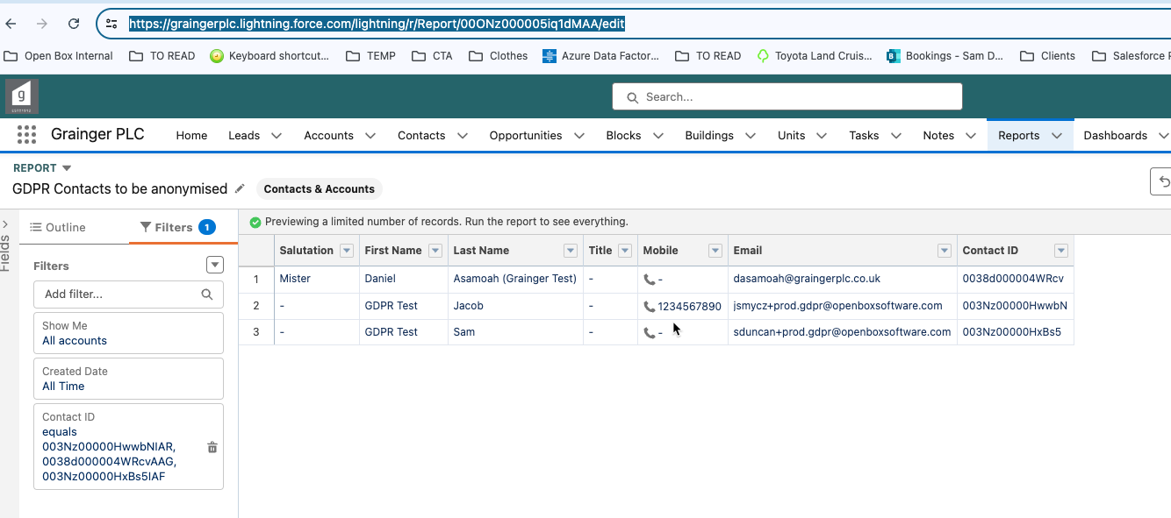

Marketing Cloud will initiate a journey using this report for source data, sending an email to all records returned by the report.

When the recipient from above report receives the email, if they click on the “Opt In URL” we are expecting the corresponding Contact record in Salesforce to be updated to have “Communication Opt In Date” = <TODAY>.

Error emails
In the case of any errors encountered during the anonymisation process (e.g. validation rules preventing a record update), the batch job will send an error email to a designated list of users setup via custom metadata type. For UAT, this email will be sent to jgeorge@graingerplc.co.uk

To test this error email, a temporary validation rule will be created on the Lead and Contact respectively to prevent updates under a specific condition (e.g. ContactId/LeadId = XXXX where XXX is the Id of a Contact/Lead that has been identified as a candidate record that is due to be anonymised by the scheduled batch). When the batch runs and the validation prevents the update of the specified records, we can validate that the error email is sent as expected.

Sanity testing
Testers are encouraged to think of other scenarios to test to cover edge cases that might have been missed. Some examples are:
- Validate that no Lead/Contact created more recently than the last 365 days has been anonymised
- Validate that no Contact linked to a Closed Won Opportunity has been anonymised
- Validate that no unconverted Lead created more than 365 days ago has not been anonymised

